Task :03 Date:27-06-2026

Sub: About Reset in git

Step 1: create the folder add files
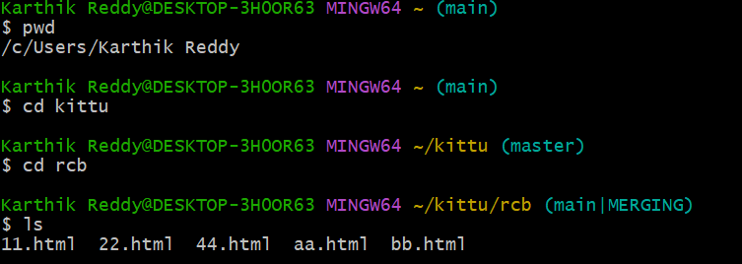

Step 2: check the how many commits was done
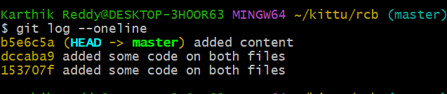
Step 3: It will come to staging area
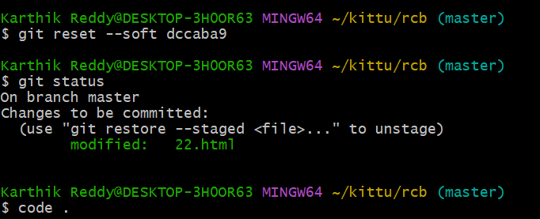
By using the this command it will go the staging area while paste the id we want to paste the pervious id
Step4: It will come to the working area
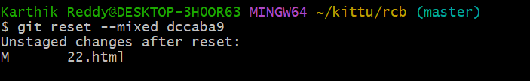
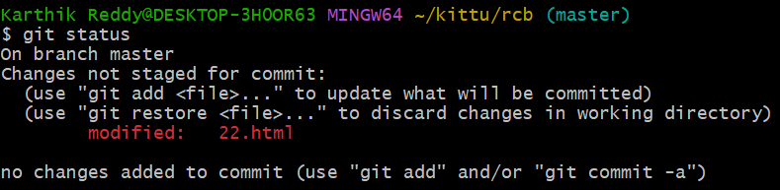
After that I was changed the code and add some content to the code.

Step5: check the commits
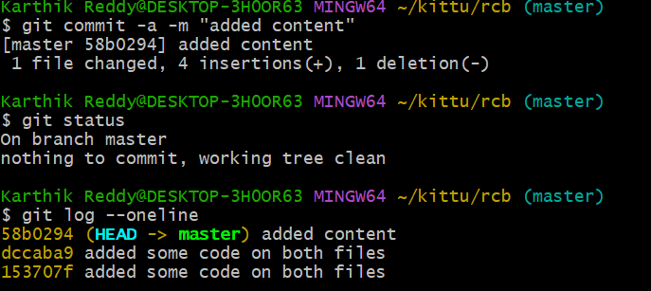
Code Enter
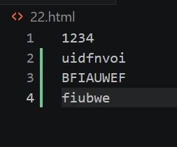
step 6:The code was reset
